Q.1) Write a Python program to count the even, odd numbers in a given array of integers using Lambda.
Code :
arr = [1, 2, 3, 4, 5, 6, 7, 8, 9, 10]
even_count = len(list(filter(lambda x: x % 2 == 0, arr)))
odd_count = len(list(filter(lambda x: x % 2 != 0, arr)))
print("Even numbers count:", even_count)
print("Odd numbers count:", odd_count)
Output :
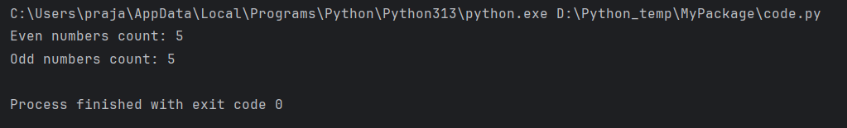
Q.2) Write a Python program to find palindromes in a given list of strings using Lambda.
Code :
words = ["prajakta", "nitin", "radar", "madam", "flower", "orange"]
palindromes = list(filter(lambda x: x == x[::-1], words))
print("Palindrome strings:", palindromes)
Output :
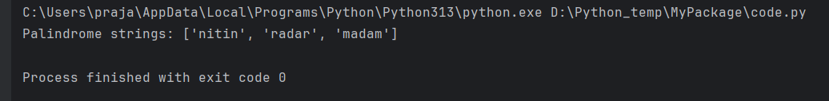
Q.3) Solve the following pattern using one loop only: accept no. of rows from user.
1
121
12321
1234321
Code :
n = int(input("Enter number of rows: "))
s = "1"
for i in range(n):
print(s)
s = s + str(i + 2) + s[::-1]

Output:
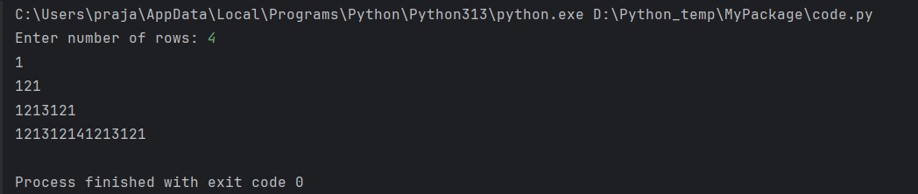
Q.4) Write a Python program to convert a byte string to a list of integers. Sample Input: “hello” Sample Output: [104, 101, 108, 108, 111]
Code :
s = "hello"
byte_string = s.encode('utf-8')
int_list = list(byte_string)print(int_list)

Output :
